

**Operating System**

**Linux**

**dMohammad Atteyah**

**202112724**

**Linux operating system**

**Linux:**Linux is a widely used free and open-source operating system, adopted by millions globally. Its versatility allows it to serve various functions, such as desktop computing, server hosting, and embedded systems.

**How to install Linux:**There are many different ways to install Linux, but the most common method is to use a live USB. A live USB is a bootable USB drive that contains a copy of the Linux operating system. To install Linux using a live USB, you will need the following:

1)A computer with a USB port  
 2)A USB drive with at least 8GB of storage  
 3)A copy of the Linux operating system

**Step by step work with pictures :**

**Here is the youtube video that i used to complete my work :**[**https://www.youtube.com/watch?v=tEh1RfmbTBY**](https://www.youtube.com/watch?v=tEh1RfmbTBY)

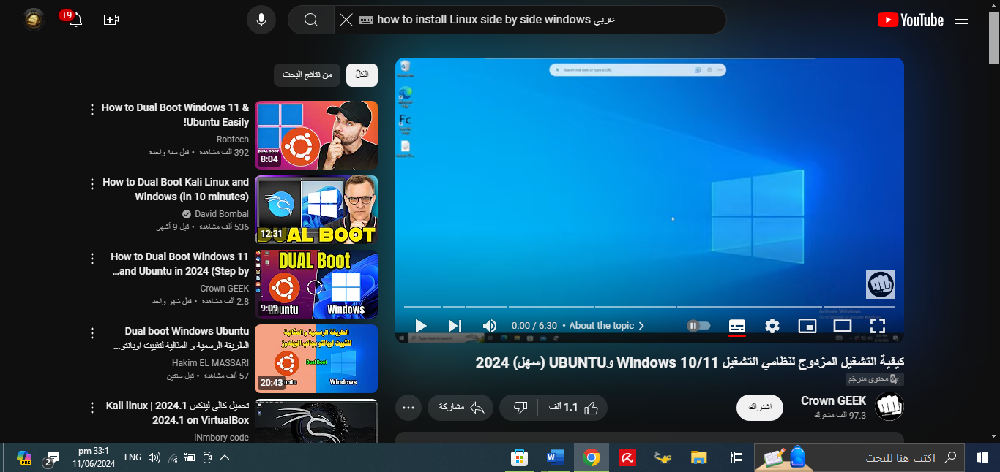

1. Going to <https://ubuntu.com/download/desktop> , and download the ubtunu from its website .

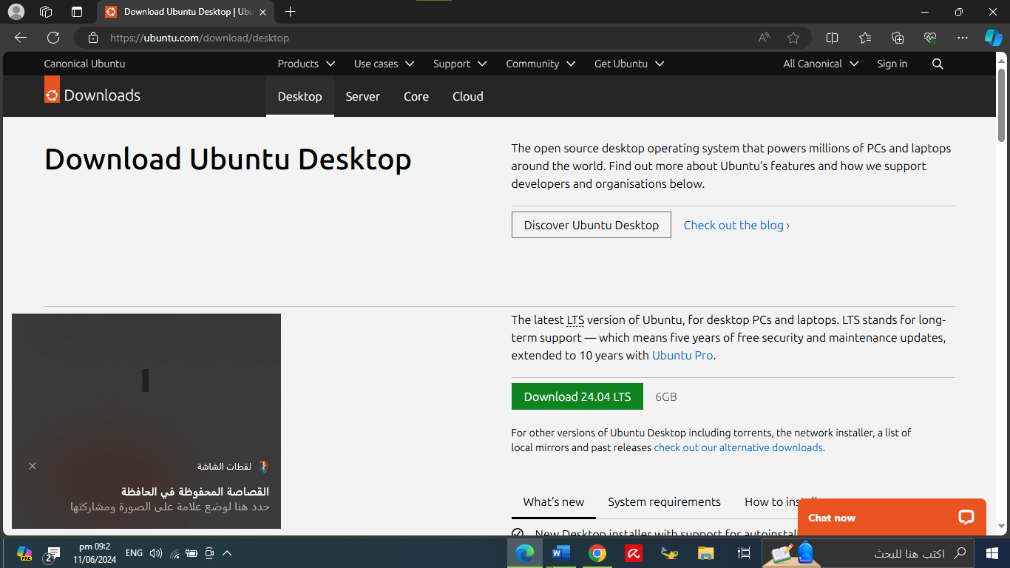

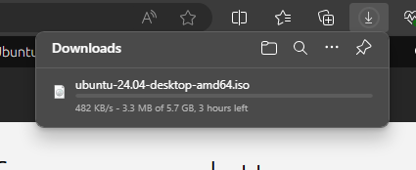

2)Download Rufus from <https://rufus.ie/en/>

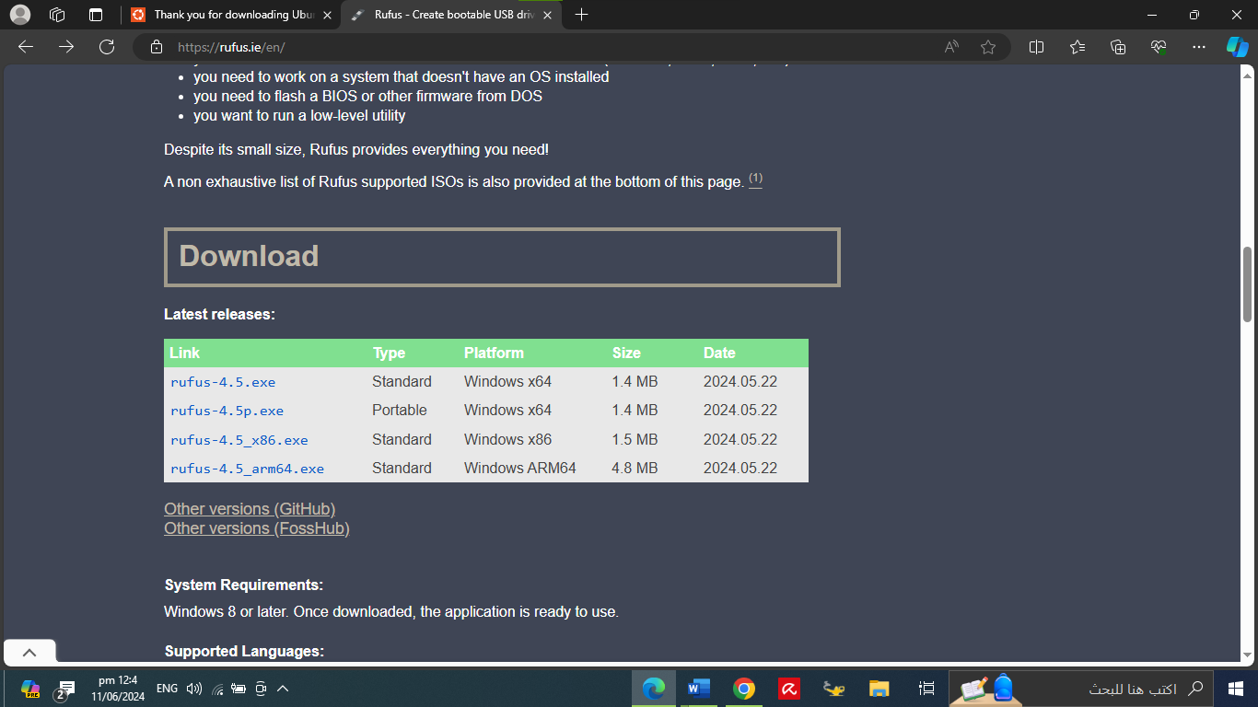  
  
3) Runing the rufus :

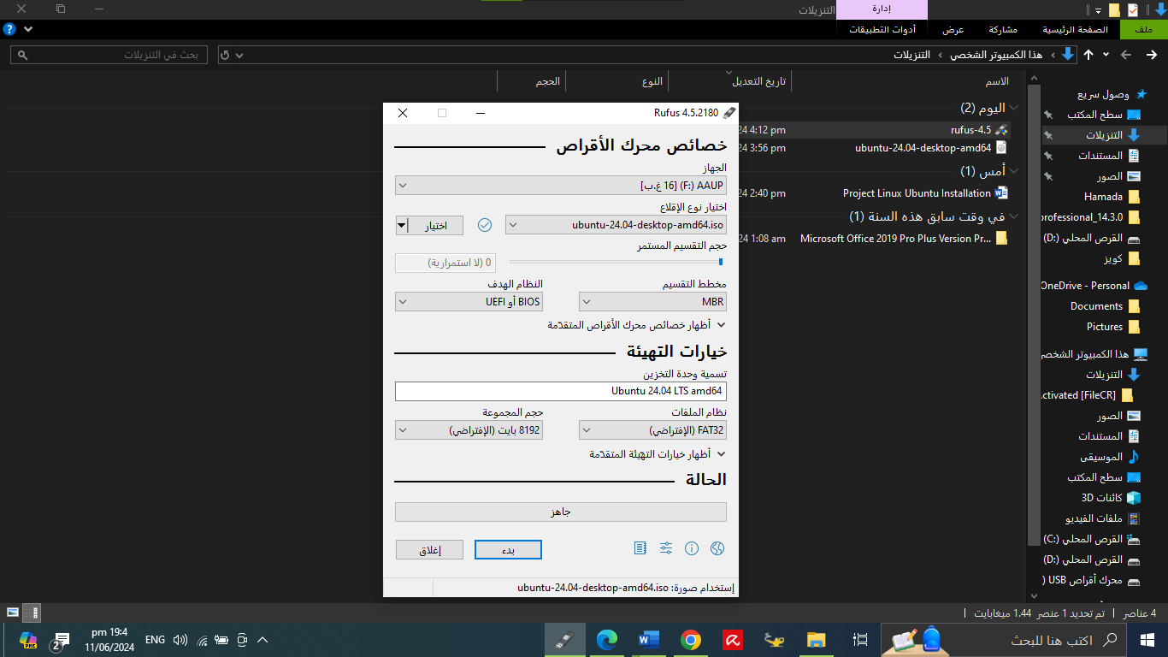

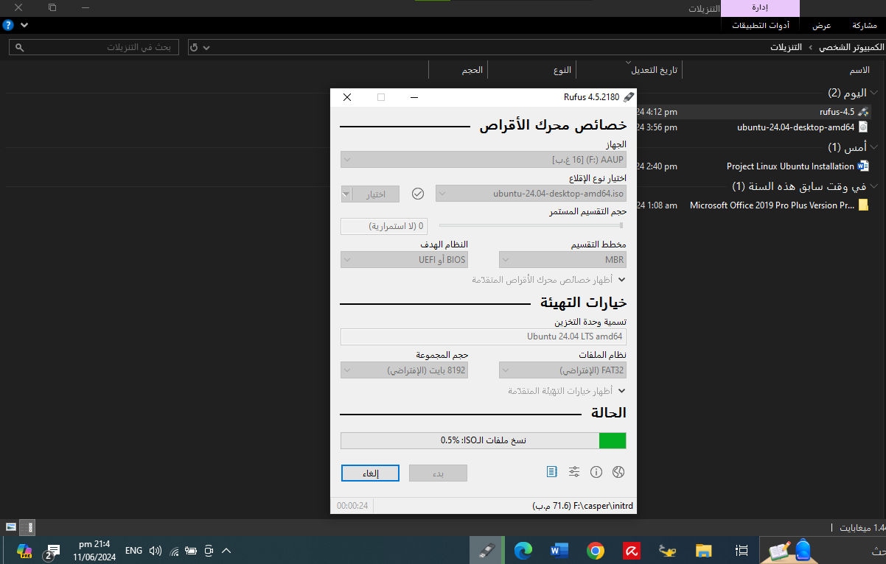

4) when the Rufus finish , restart the computer on bios mode :

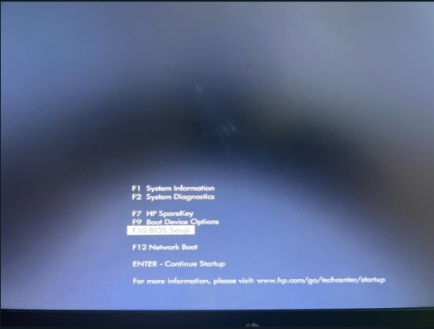

5))Prepare the computer to boot from the flash drive :

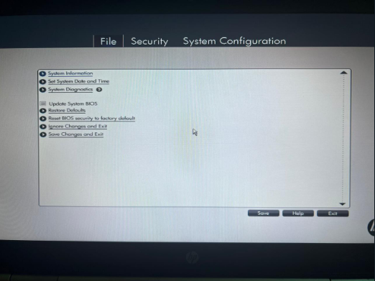

6) after boot from the flash drive we need to install the ubtuno :

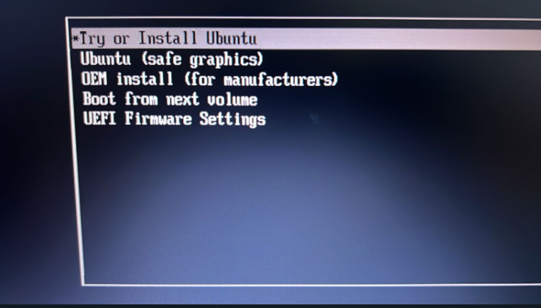

7)choose the language interface:

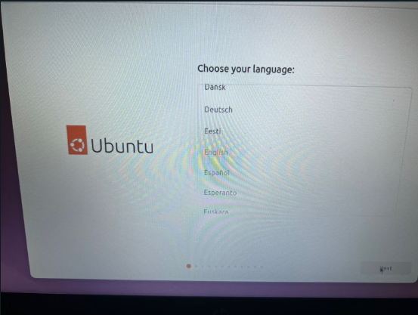

8)customize you need fot accesbility :  
  
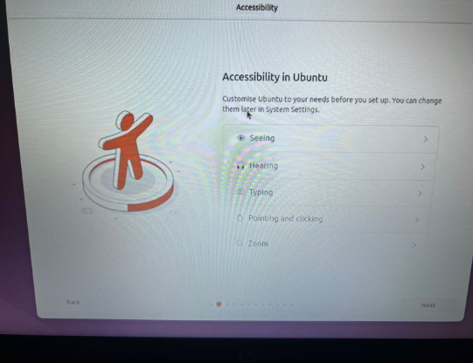

9)choose you Keyboard leyout:

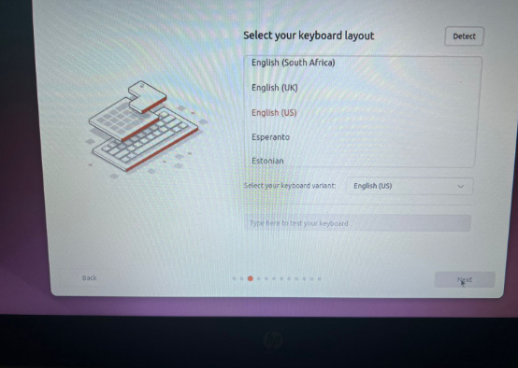

10)

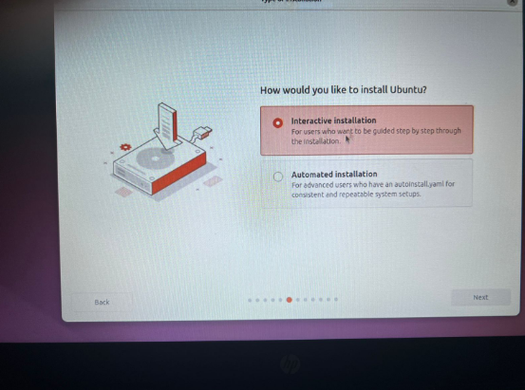

11)

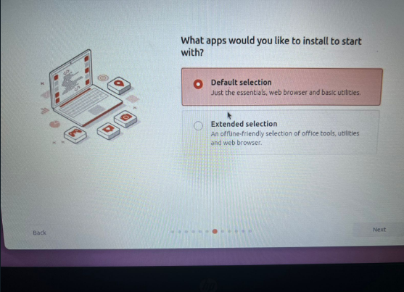

12)

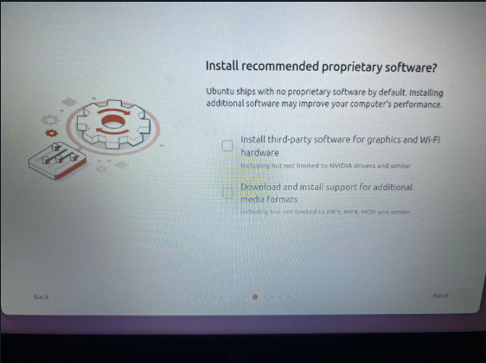

13)

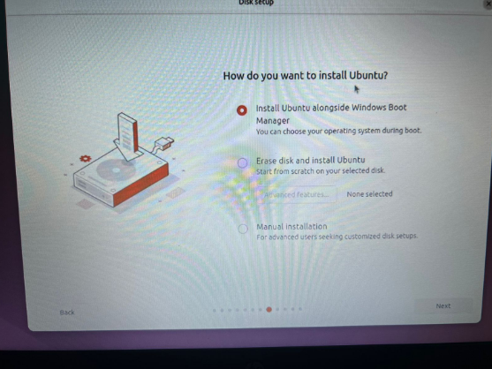

14) The desktop of the Ubtunu Linux

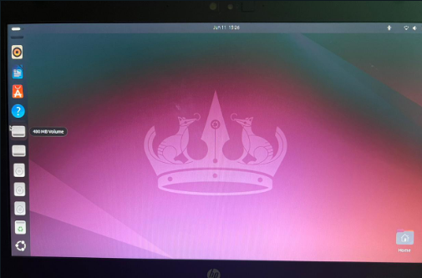

15) opening Terminal ( ctrl + alt + T )

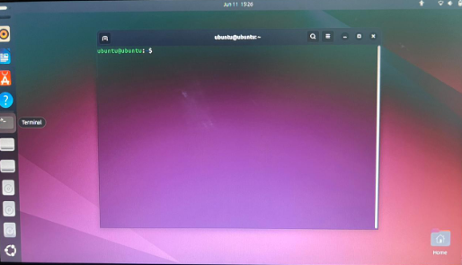

16)creating file on desktop :

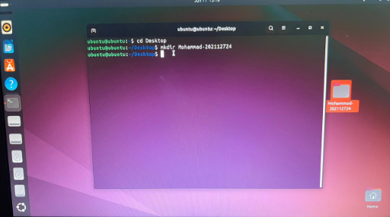

17) create a file inside the first file:

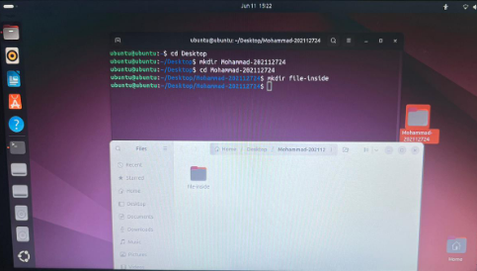

18) create txt file :

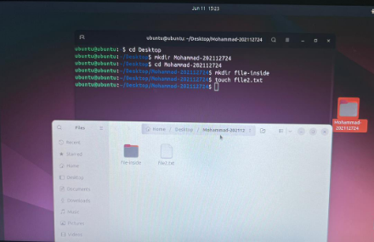

19) the Terminal window with all commands

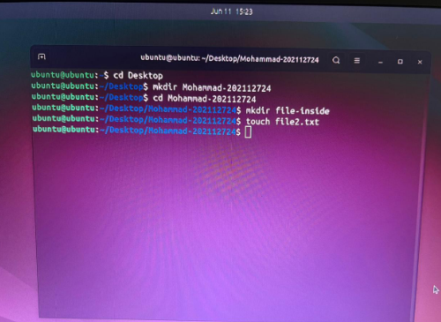

Conclusion :

The Linux operating system is a remarkable example of how open-source development can lead to widespread innovation and impact. From its humble beginnings as a personal project to its current status as a critical component of global technology infrastructure, Linux embodies the ideals of flexibility, security, and community-driven progress. As technology continues to advance, Linux is poised to remain at the forefront, driving new innovations and shaping the future of computing.